**Bugs**

**Identifier: BUG_PHA01**

**Summary:** Hashing creation with Invalid key should not create hash

**Priority:** Low

**Severity:** Moderate

**Description:** When user creates a hash, if they use an invalid key the hash is created anyway.

**Steps to Reproduce:**

1. Connect to hashing password application
2. Send request to Endpoint to create hash
3. Modify the key for an invalid key. e.g:

$ curl -i -X POST -H "application/json" -d "{\"contrasena\":\"angrymonkey\"}" <http://127.0.0.1:8088/hash>)

**Actual Behavior:**

When creating a hash with an invalid key, the hash is created anyway

**Expected Behavior:**

When creating a hash with an invalid key, the hash can’t be created and an error message is displayed “Malformed Input”

**Evidence:**

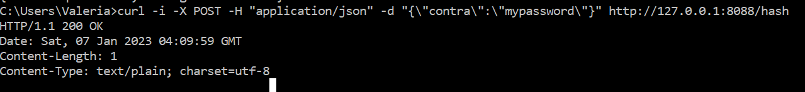

**Product:** Hashing Password Application

**Identifier: BUG_PHA02**

**Summary:** SHA512 hash is returned instead of base64 encoded password

**Priority:** High

**Severity:** Critical

**Description:**

When user sends GET request to get the base64 encoded password the hash SMH512 is returned instead.

**Steps to Reproduce:**

1. Connect to hashing password application
2. Send request GET to Endpoint to get base64 encoded password

**Actual Behavior:**

When sending GET request the base64 encoded password is NOT returned, SMH512 hash password is returned instead.

**Expected Behavior:**

When user sends GET request to validate encoded password, the base 64 encoded password should be returned

**Evidence:**

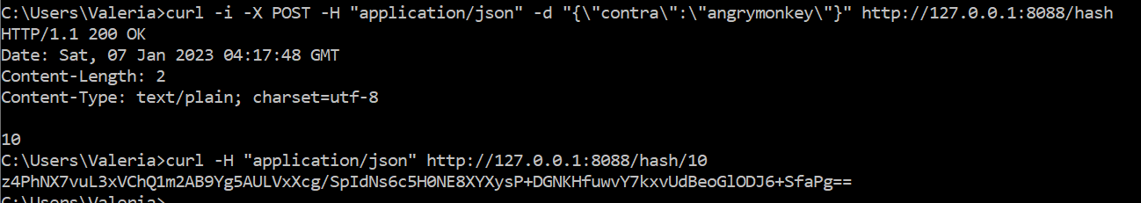

Base64 encoded for “angrymonkey”: **YW5ncnltb25rZXk=**

**NOTE: This issue was created based on the Acceptance Criteria in Requirements. However is more likely that the requirements are incorrect and this is a bug that should have been found during static testing, where the correct is that the SMH512 hash should be returned when user sends GET Request.**

**Product:** Hashing Product Application

**Identifier: BUG_HPA03**

**Summary:** SHA512 hash is returned instead of base64 encoded password

**Priority:** Low

**Severity:** Moderate

**Description:**

Average time in statistics is not accurate. It takes about 5 second to complete request as described in requirements.

**Steps to Reproduce:**

1. Connect to hashing password application
2. Send request GET to Endpoint to get statistics

curl http://127.0.0.1:8088/stats

**Actual Behavior:**

Average time in statistics is not accurate.

**Expected Behavior:**

Average time in statistics is accurate to time it takes to complete the POST request.

**Evidence:**



**Product:** Hashing Product Application